**Title (Bold Times New Roman 16)**

**First Author1*, Second Author2** (Bold Times New Roman 12)

1Affiliation (Times New Roman 11)

2Affiliation (Times New Roman 11)

*Email of Corresponding Author: ------@---- (Times New Roman 11)

*Received: Accepted:* (Italic, Times New Roman 10)

**Abstract**

The abstract must be formatted in Times New Roman, size 12, with single spacing. It should contain between 150 and 250 words. Each A4 page should have margins of 20 mm on the left and right, 25 mm at the top, and 20 mm at the bottom. The abstract is to be placed on the first page.

**Keywords**

Use Times New Roman, size 12, and separate keywords with commas. The number of keywords should range from 3 to 6.

**1. Introduction**

Dear authors should note that the manuscript must be written in 4 pages. The body of the paper should be in Times New Roman, size 12, with single spacing throughout. All main sections (Introduction, Materials and Methods, Results and Discussion, Conclusion, and References) must be bold with capitalized first letters and numbered (e.g., 1. Introduction, 2. Materials and Methods). Subsections should be italicized, numbered, and formatted as Each Word.

*2.1. Italic Word of Title* Continue text

*2.2. Italic Each Word of Title* Continue text

*2.3. Italic Each Word of Title* Continue text

All equations must be numbered distinctly and referenced in the text, as in Equation (1). They should be created using Microsoft Office's Equation feature.

*∂u​/∂t +(u⋅∇)u=−1/​* *ρ ∇p+ν∇2u+f* (1)

In the text, refer to tables and figures as Table 1 or Figure 1. Figures should have a resolution between 300 dpi and 600 dpi, without borders, and the axis titles should begin with a capital letter and include their units. The font for table content should be Times New Roman, size 11.

Table 1. Comparing the mechanical properties of aluminum and iron (Times New Roman 10)

|  |  |  |
| --- | --- | --- |
| Property | Aluminum | Iron |
| Density | 2.7 g/cm³ | 7.87 g/cm³ |
| Yield Strength | 70-400 MPa | 250-800 MPa |
| Tensile Strength | 90-550 MPa | 370-1,200 MPa |
| Elastic Modulus | 69 GPa | 210 GPa |
| Poisson's Ratio | 0.33 | 0.29 |

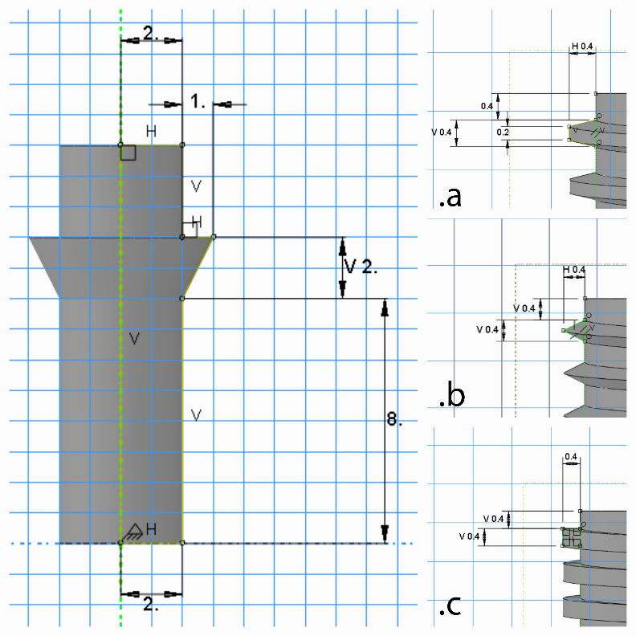

Figure 1. Design of the implant with three different threads: a) Model 1 with a trapezoidal cross-section, b) Model 2 with a triangular cross-section, c) Model 3 with a square cross-section. (Times New Roman 10)

**2. Acknowledgment** (optional)

Any acknowledgments can be included in this section.

**3. References**

References must be listed in a separate section at the end of the manuscript, typed single-spaced, and in the order they are cited, using numerals in square brackets. Include DOI or DOR identifiers at the end of each reference when available. All references should be written in English, following the provided examples.

**Journal**:

[1] Pathak, A., Sivakumar, G., Prusty, D., Shalini, J., Dutta, M. and Joshi, S. V. 2015. Thermal spray coatings for blast furnace tuyere application. Journal of Thermal Spray Technology. 24(8):1429-1440. doi: 10.1007/s11666-015-0350-z.

[2] Rahmani, F. and Hashemi, S.J. 2021. Numerical and experimental investigation of thickness distribution in hydromechanical deep drawing process of square parts. Journal of Modern Processes in Manufacturing and Production. 10(2): 5-12. dor: 20.1001.1.27170314.2021.10.2.1.2.

**Book**:

[3] Khalid, M., Omatu, S. and  Yusof, R. 1995. Neuro-Control and Its Applications. London: Springer-Verlag.

**Conference proceeding**:

[4] Horiba, Y., Kobayashi, S., Akita, H. and Usami, H. 2013. Friction properties of MoS2 penetrated aluminum alloy. Proceedings of JAST Tribology Conference. Tokyo, Japan.

**Thesis:**

[5] Hashemzadeh, M., 2014. Investigation into fibre laser cutting. The University of Nottingham. Ph.D. thesis.

It is recommended to use the **MPMPJ style.**